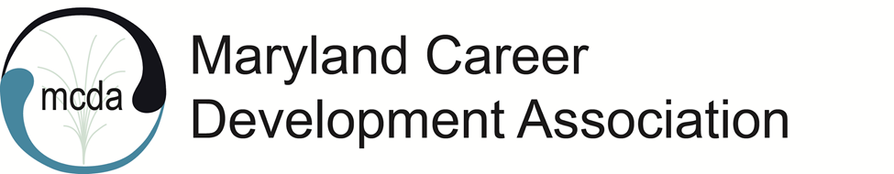
MCDA Board Meeting
Friday, June 10, 2022, 11:00 am
Virtual via Zoom

Present: Natasha OrtizFortier, Kimberly Mills, Marilyn Maze, Natalie Kauffman, Karol Taylor, Rose Howard, Jennifer Longmire-Wright , Staci Parker, Latara Jones

President OrtizFortier called the meeting to order at 11:01 am.
President OrtizFortier welcomed everyone to the meeting.
Minutes from the MCDA May 2022 virtual meeting were approved.

2022-2023 Board Election Updates
Natasha said that we have treasurer, and secretary, and past president.
Karol said that Staci is running for president, but there is no president elect. Staci did a nice post in the MCDA newsletter about needing a president elect. We can also post in the MCA weekly digest. It is free to sign up for the digest.
Kate Rizzi is running for Treasurer Elect.
Natasha reminded that president, president elect, treasurer, and secretary must become members of MCA, ACA, and NCDA in addition to MCDA. This is in the MCA Bylaws. MCDA will cover the cost for MCA, ACA, and NCDA for the upcoming term if the elected officers are not already members of those organizations.
- Karol noted that we have not voted on this. The Board discussed and voted in the Zoom chat. Every vote was “yes”.
Marilyn will do the email switches for the new Board members. She will also send out the election slate.
Natasha thanked everyone for trying to recruit for the Board and the committees. Karol suggested we contact Laura Labovitch and possibly Elle O'Flaherty, ESQ to serve as committee chairs. They expressed interest in being a chair.
Staci noted that there will be a series of webinars for MCDA members about improving their business, practice, and professional skills. The first one will be next Saturday. However, she does not have the Zoom link. Marilyn said we should set up an official event, which would include reminders and a Zoom link.

Virtual Assistant Update
Natasha said we have one candidate and asked the Board how to proceed. Staci said she liked the candidate’s resume and would like to interview her. Natasha will participate in the interview too and possibly Rose. Staci suggested for the Board to submit questions for the interview.
Marilyn will train the virtual assistant on Wild Apricot.

Last MCA Board Leadership Team Meeting
Natasha shared important information from the meeting: MCA is planning to require each division to follow an established base price for their membership and base price for their programs. Some divisions disagreed. MCA asked for the for feedback from the divisions and they will make their decision regarding the base price during the next meeting.
The Board discussed how to advocate regarding this matter. One consideration is members paying certain fees for programs with CEUs. While the CEUs are very valuable, many members and attendees, do not need it. Natalie noted that MCDA has the largest number of divisional membership than any other divisions of MCA. Therefore, our feedback is valuable.
- Natasha will pass on the feedback.

Website - Marilyn Maze
Marilyn will provide training for the new Board members.

Programming – Kimberly Mills
Jeff is still interested in presenting on LinkedIn. Bonnie is still interested in presenting on adversity and women in the workplace. The plan is for both to present in the fall.

Credentialing – Rose Howard
Rose has a concern from the last conference and will reach out to Kimberly about it.
Karol noted that future conference links should go out in advance to avoid people emailing about it.
Rose asked if everyone who applied for the CEs, received the CEs for the keynote speaker, which were not included in the first CE certificate for the other presenters. Rose clarified that it did not get included in the beginning because we did not have the required information.
Rose also noted that in one presentation there was one unplanned speaker (only one presenter completed the paperwork). This is a concern because the speaker did not have the same qualifications. Rose reminded that all presenters must submit the paperwork.

Legislative Updates - Natalie Kauffman
The White House will start paying their interns $750/week per intern beginning this fall. More information is available on the legislative page.
The ACA and MCA advocacy groups are cooperatively putting on Federal Hill Days. On June 15, 2022 ACA will talk about congressional meetings and other topics of interest to counselors. MCA will follow up with the Maryland congressional representatives the following week. ACA require membership to register for the Hill Days, however, MCA do not require membership to register for theirs.

Karol Taylor
Karol reminded everyone that she will not continue with the Board. She will be available for advice.

Thank you from Natasha
Natasha thanked everyone for serving with her this term.

Adjournment 12:09
Minutes taken by Viktoriya Selden

