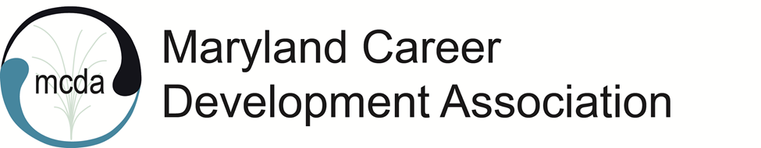
MCDA Board Meeting
Friday, November 12, 2021, 11:00 am
Virtual via Zoom

Present: Natasha OrtizFortier, Latara Jones, Natalie Kauffman, Marilyn Maze, Tessa McKenzie, Kimberly Mills, Viktoriya Selden, Karol Taylor, Maria Schaeffer, Rose Howard, Paula Waters

President OrtizFortier called the meeting to order at 11:12 am.
President OrtizFortier welcomed everyone to the meeting.
Minutes from the MCDA September virtual meeting were approved.

MCDA Spring 2021 Conference - Natasha OrtizFortier initiated the discussion.
- Title: Career Pivot?
- Date: April 28, 2022
- Time: virtual conference from 9 am to 3 pm with a live happy hour from 5 pm to 7 pm.
- Platform: zoom
- Location of the happy hour: TBD
- Price: TBD
- A call for proposals will be sent out soon.
The details will be discussed during the conference committee meeting on December 10, 2021

Emerging Leader’s Program – Natasha OrtizFortier reviewed the program and options for how it could benefit MCDA and MCDA members.
- She asked the Board members to consider if any two individuals would participate.

Meeting of the Minds - Tessa McKenzie said that the meeting went well, and the team expressed an interest in meeting regularly. Some of the common interests expressed were emerging media and leadership development. Keeping a shared calendar was suggested. A common concern was the struggle to maintain membership.

Financial Update - Maria Schaeffer:
- There has been no news from MCA, so current budget is unknown.
- Since July 2021, the only income has been $600 from membership. Membership has dropped from 100 to 68 active members, 11 of whom are lifetime members.
- Wild Apricot costs $2,050/year
- Lisa’s services cost $473/year
Maria said that she will continue to follow up with MCA.

Committee Updates
Programming - Kimberly Mills spoke about past and upcoming presentations.
- Regarding the “Soft skills” presentation:
  - 44 participants signed up, 21 participates showed up, and only 7 were members.
  - There were technical issues with Zoom, some couldn’t get into the presentation.
  - No CEUs were provided. Presenter indicated she would not offer clock hours.
  - Students need clock hours. This should be considered for future presentations/webinars.
- Karol will presentation on December 3, 2021.
- There will be a presentation in February 2022.
- There was discussion around increasing revenue. Karol said she attended a presentation and they charged $40.00 for non-members, $30.00 for members and $15.00 for retirees and students.

National Career Development Month – November 2021. Latara Jones:
- There is a public charter school interested in working with MCDA, but not at this time. It is a possibility for the future.
- On November 19, 2021 Dr. Jodi Frey from University of Maryland School of Social Work will offer a free presentation on wellness in partnership with MCDA.

Membership – Natasha OrtizFortier informed the Board that Dennis Weeks has accepted other work and will no longer be available to serve on the Board. The membership position is now open.

Advocacy Updates - Natasha OrtizFortier said that Natalie Kauffman has updated the legislative pages.

Credentialing and CEUS – Rose Howard said there were no updates.

MCA Updates - Karol Taylor:
- She will discuss with MCA their new bylaws and how it effects MCDA. One concern is the requirement for the executives of all organizations to be members of ACA, MCA, and the national organization. Karol is continuing to advocate against this so that additional fees are not required.
- MCA’s next meeting is November 16.
- An option to explore is disconnecting from MCA and being chartered by NCDA. Lots to consider, including NBCC hours (currently MCDA is tied with MCA).

MD Cares – Tessa McKenzie:
- She reached out to last year’s participants, but received little response. Everyone is at max capacity and unwilling to commit at this time.
- It is a great service and is there a way to bring it back?

Adjournment
Minutes taken by Viktoriya Selden with contribution from Paula Waters
Next Meetings:
- Friday, December 10, 2021 MCDA Virtual Conference Committee Meeting (elected board members are the base of the committee, however, all are welcome to join).
- email Natasha if you’re interested in joining the conference committee
- Friday, January 14, 2022 MCDA Board Meeting 11:00 a.m.-12:15 p.m.
- Thursday, December 16 Happy Hour/Meet the Board TBD

